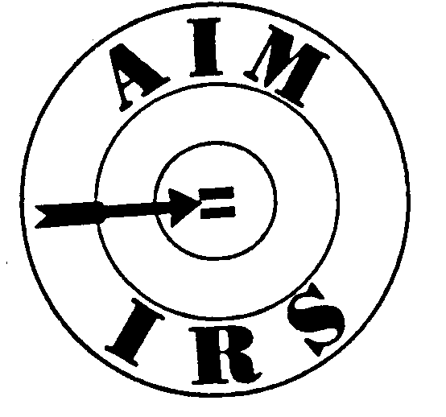

Association for the Improvement of Minorities

April 01, 2018

Dear Regional Vice-Presidents, Regional Representatives and Chapter Presidents:

We will elect a National President and National Senior Vice President in Orlando, Fl. Now is the time for us to consider who is qualified and capable of leading our organization for the next two years. The National Bylaws specify the qualifications necessary for these positions:

Article IX Section (2)

1. No person shall be elected President or Senior Vice-President unless at the time of election that person shall have served two (2) years on the Board of Directors. Any qualified person may stand for election to one (1) of said offices at any biennial election. A candidate must be an active member in good standing in the region and chapter from which the candidate is nominated during the entire twenty-four (24) month period immediately preceding such candidate’s nomination.

Candidates should also have demonstrable leadership skills; ability to communicate effectively; knowledge of Parliamentary procedure; knowledge of the Bylaws and standing rules of AIM-IRS; knowledge of the organizational structure, purpose, goals, history of AIM-IRS; and knowledge of the organizational structure of IRS.

The Nominating Committee is charged with soliciting nominations and certifying the validity of potential candidates. To that end, we request that all nomineessubmit a detailed nomination form outlining their qualifications for said position. The nominee should also submit an essay outlining their vision and goals for the future of the organization (must provide specific examples).

The nomination and essay must be submitted timely in accordance with the deadlines. **Due date for submission of the nomination form is April 30, 2018. Due date for the submission of the essay is May 15, 2018.**

**Nomination Information should be sent to**: Cheryl Green

P. O. Box 84617

Seattle, WA 98124

Msannvegas053@gmail.com

Should you have any questions or require additional information, please feel free to contact

me at 206-605-0266.

I look forward to your participation in this process which is vital to the future success and progress of our organization.

Sincerely,

Cheryl Green, Chair, Nominating Committee

cc: National President

National Senior Vice-President

National Recording Secretary

National Executive Secretary